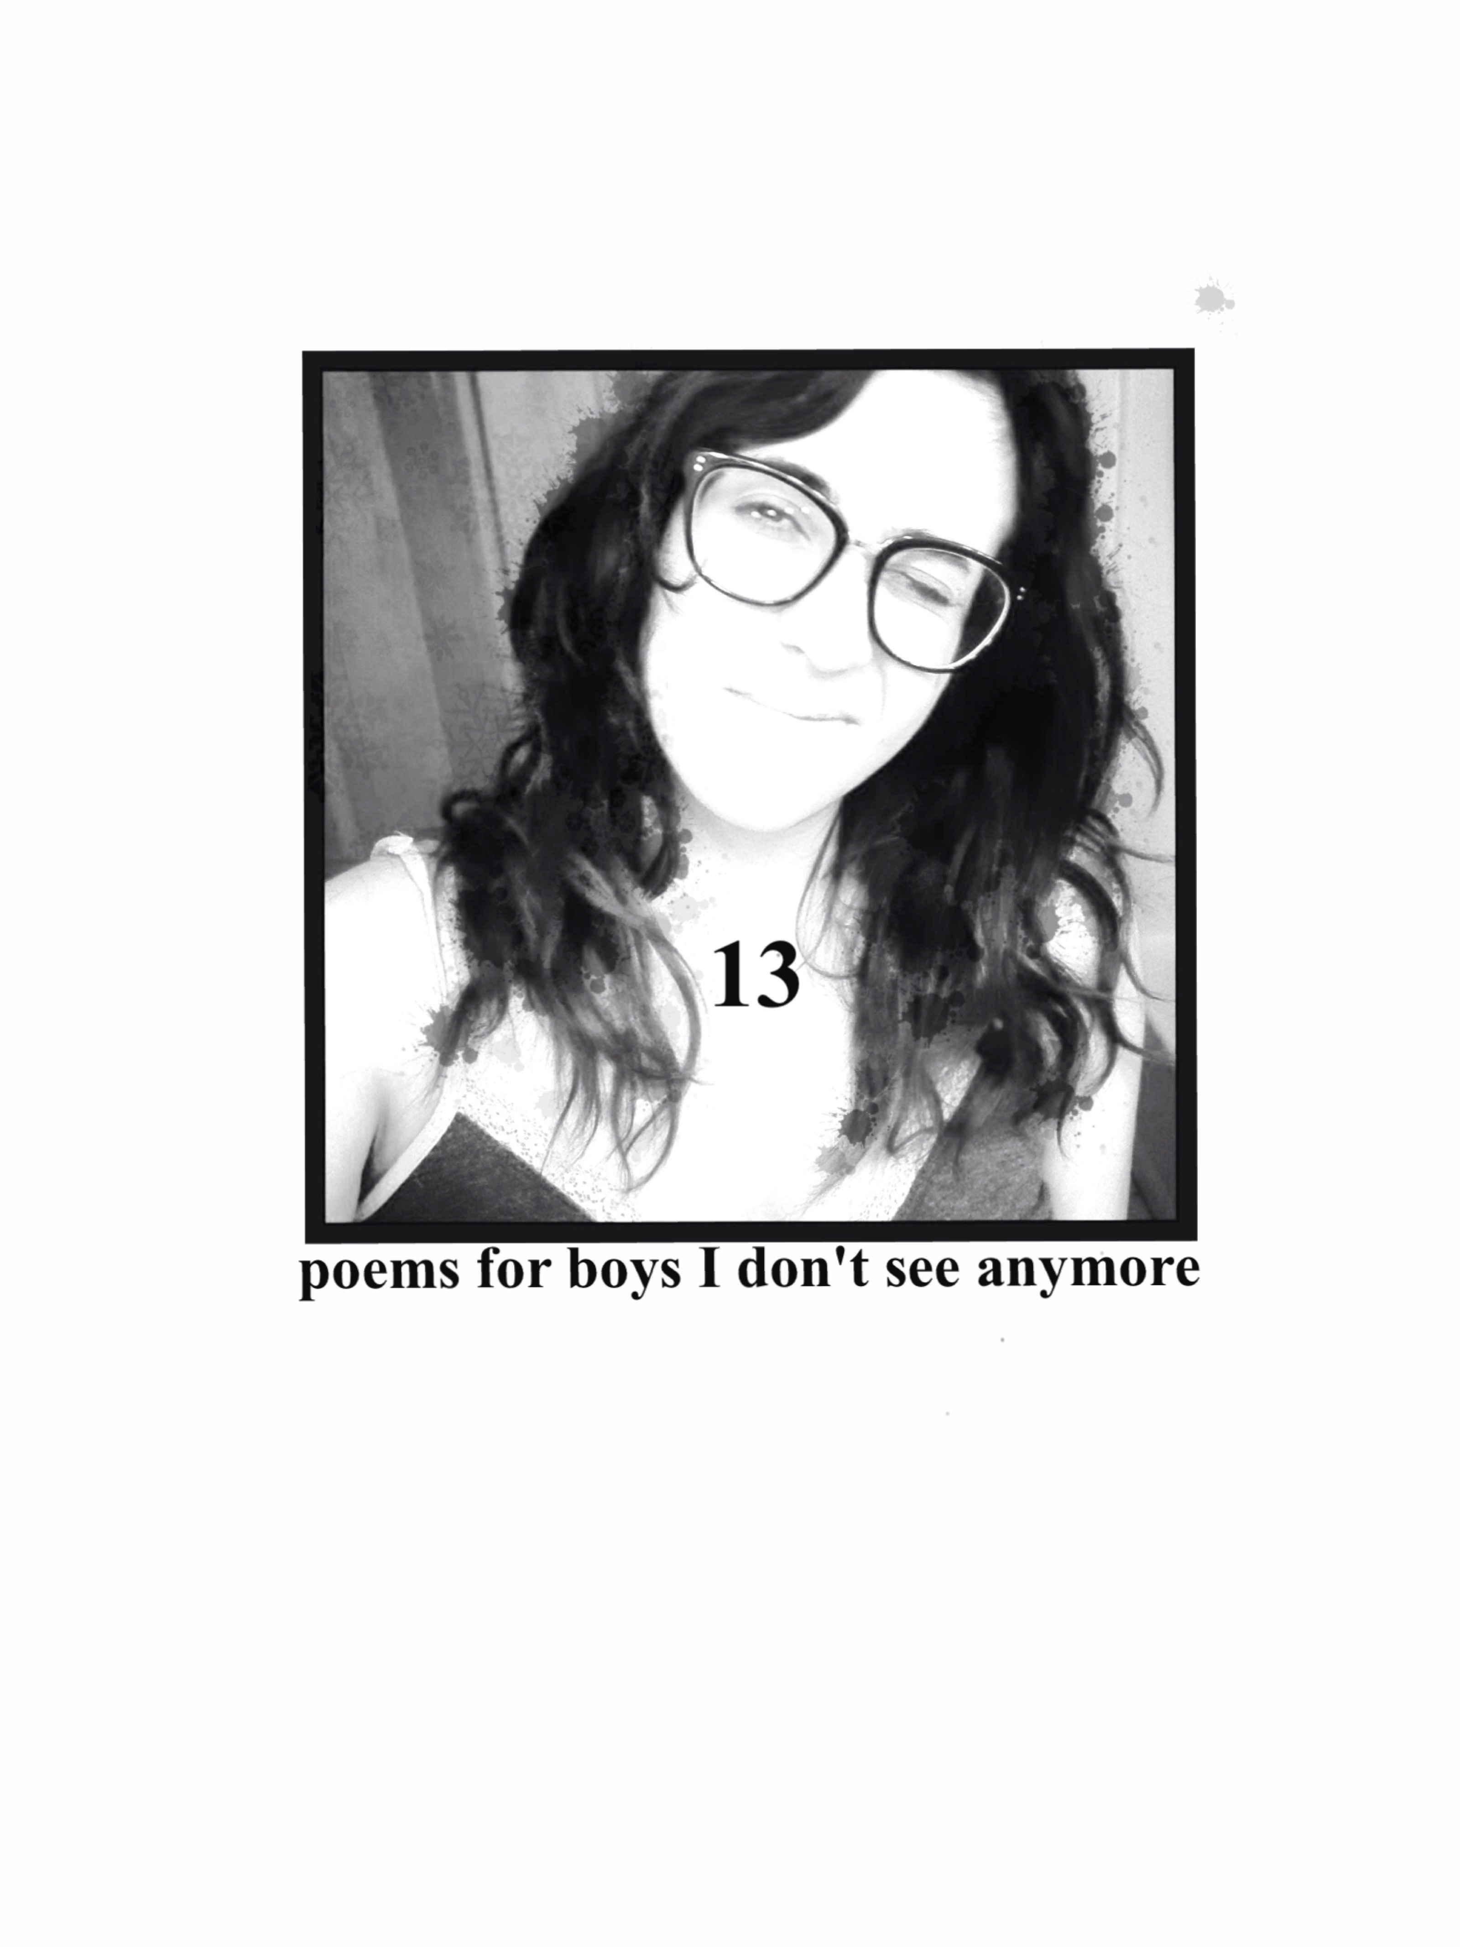
Complete. And. Still growing.

Its quiet here
in my little house
in my dusty town
I like it.
my life
singular in my village
of friends I;ve fought for
Time chasing inspiration
on bicycles
Any way I like
The freedom to find company
over drinks or
between sheets or
dream alone at home

Brave

I sipped my own embarrassment
with too much cinnamon
In a coffee shop id never been to a hundred times
I stepped out.
Wind blowing up the downtown buildings into
towering specters
I fell. Flat on the flagstones leading to a beginning I was
trying so hard to force
I smiled. I tried on new people like thrift store clothes
that feel soft but smell wrong
I’m looking for my arbitrarily assigned center

Would you like it to be you?

christmastryst

So that happened
After an exact year of wanting
And it went like this
I touched your hair, laughing
And you kissed me with amazing momentum
Like you’d been headed that way for a while
And we fell back into
Every lusty dream we sent each other
And there was a moment
We heard a noise and sprang apart

I knew then what you’d say
That we couldn’t be together
Or shouldn’t
But you turned to me and asked instead
“Should I shut the door?”

Pike Place

I’m going to go
find green things to grow
on my own
with two hearts
a handful of suitcases
a goldfish
and some fifty cent dreams

I have to follow the river
Not because of where it goes
But because of where it comes from

Three kisses wishes

The first was with a laugh, right?
it was big but also shy
an expriment in friendship potentiel

The second was right between
shared intellectual pursuits
and fuzzy dreams on different continents
When I pulled at your sleeve
And bit your lip

But the third was not discouraged
by the parking lot, or suburbanites, or the sweet fat rain
drops clinging to your dark curls
And it swept me
up as high as my toes would take me and all the way
down to my watery knees
All around because you folded me in
your smokey small
strong arms
scratchy face
A chest wide enough to wear a variety of
fancies

Sudden. Scary.

Theres been some number
Of hands that have hovered, or rubbed fondly, caressed or
Pressed hard with passion
My skin
Tea without milk. Sugaring sun

But

There has been only one
Small, mean eyed mad
Who put his hands on me
With nothing in his mind
But pain

word shapes.

entranced
by the symbols you put together
building filaments
fiber optic fairy bridges
meanings and little
punctuation promises
that we will trace
fingers on skin on skin
with
mouths that stop speaking
and start loving

Calluses

Your hippy-ass incense
won’t come out of my shirt
And now pieces of my closet
are memory traps
Not for you, not really
just all the hopes I made

Biscuits

pouring sweet rain, every time
heady things curl like toes
sweat beading on open mouths
an impossible handprint on a foggy window
never so surprised
when he’s around
the only time I stop laughing is when I’m kissing him

Haunted

These cold sheets still remember
how we'd fall asleep
in the strangest positions, baby.
Noses touching
faces making hearts
in negative space.
Or hands entwined,
thrust up where the pillows were before we made dark wild love
my back arched
your dreams and breath at my breast free fingers stroking lazy
hopeful
circles
on my soft stomach

Robots.

I’m tired of measuring
How much I like someone
By how much I think it will hurt when they leave

My heart is a vessel for something I don’t fully understand

Give me a moment
between breaths
behind doors
under the covers
hidden from all the hurts we might cause

I wrote this sonnet for a contest and it did not win.

it’s a snow day in Austin
incremental ice on the ground
and me and this here computer, we’re aiming for profound
cause my body’s still fighting off frost and
being a robot’s exhausting
I need a date with a song
black eyes burn the night long
But, Bob, your shows lately are costing
so many silver tongues
Too much for this broke ass heart
a blue collar state of the arts
I’ll pay these words like a black lung
breathing back into a false start

